Center For Intelligent Systems

ISAC Technical Arm Manual
Adapted for IMA 2.5

Juan Rojas
January 2006

Table Of Contents

- Introduction p.1
- Hardware Report p.2
- Theory p.3
  - Angles p.3
  - Kinematics p.3
  - Control Loop p.4
- Right Arm Agent p.5
  - Components p.8
- State Machine p.14
- Conclusion p.16
- References p.17

Introduction

This manual is intended to be a comprehensive guide to ISAC’s arms. Through this guide you will be able to learn about its hardware, and the theory and software components that go along with it. A description of the Right Arm Agent and its essential components will be included along with an explanation of the sequence of events in the state machine that runs this agent in the Distributed Agent Designer (DAD) for IMA 2.5.

Historically, the arm has been controlled in a variety of ways in different operating systems. Currently there exist controllers for the arm in Windows – through direct executable programs, and through IMA 1.0, and IMA 2.5. There also exist controllers for the arm in QNX (under POPEYE) and in Linux (under HUNGERFORCE).

This manual will mainly refer to the work done for the arm under the IMA architecture in its most updated version at this point in time, which is IMA 2.5. The difference between the arm controller used in version 2.5 and that of its predecessor is that in version 1.0, the RightArm Agent contained and could run a complex controller based on Tonic & Phasic activation levels. This was a project done under Steve Northrup. You can find documentation for his work under the I:\ drive in the Documentation folder, in PH.D. Dissertations. Under IMA 2.5 the Arm Agent only runs a PID/Non-linear controller also used in prior versions.

Hardware Report

The ISAC arms are six degree-of-freedom (DOF) serial robot manipulators. Its actuators are pneumatic muscles called Rubbertuators.

The Rubbertuator is a pneumatic artificial muscle. Pairs of Rubbertuators work in opposition to move a joint, just as animal muscles do. Rubbertuator joints have some disadvantages; for example, hysteresis and non-linearity. They are, however, lightweight and consume less power than DC motors.

A common scheme for position-based control of a Rubbertuator joint is to inflate each Rubbertuator to a bias value. The joint input is then the pressure difference, ΔP, between the two Rubbertuators. A servo loop then commands ΔP, using angle feedback. Most control laws for Rubbertuator joints are position based; that is, the controller tries to achieve some desired joint angle. Several schemes, including PID and neuro-fuzzy, have been used to control position. In the ISAC arm, researchers have used PID controllers, non-linear controllers, and tonic-phasic controllers. The IMA 2.5 Arm Agent currently uses a PID/Non-linear controller adapted from the IMA 1.0 version.

The airflow for the arm is shown in Figure 1. Starting the Fall of 2006, the air intake was changed from the compressor in room 125 to the air valve located on top of the black counter in the lab. This was done to improve the quality of the air. The new air is considerably less humid. The air travels to the storage tank (which is regulated at an approximate pressure of 65psi). Air from the storage tank passes through several filters (large-particle filter, humidity filter, and then through the freezer – to cool the air – and again through another set of similar filters) to the valve arrays for the left and right arms. Previously the air was also used for the Pneu-Hands (air-muscle hands) that are no longer used. It is important to pass the air through the dryer because impurities, such as oil, can be harmful to the Rubbertuators and the servo valves.

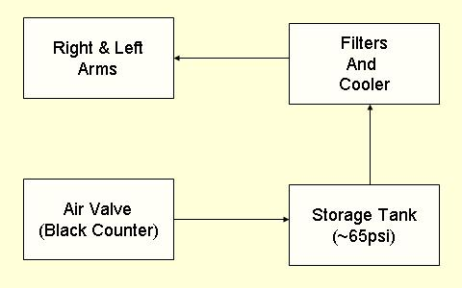
Figure 1 – Airflow

In 2007, a new systems of mini-valves were purchased along with compact filters. The system will work the same way but is now more compact.
The new cards are:
- 7541 MOTENC-Lite PCI Board. 4-Axis Motion Control Card
- 7535 I/O Termination Board for MOTENC-Lite
- 7525 ENC/DAC/ADC Termination Board for MOTENC-Lite
- CB51 50 Pin Ribbon Cable, 1 meter (Twisted Pair)
(http://www.vitalsystem.com/web/motion/motionLite.php)

Note!!
This documentation does not apply for the new valves!!

Theory
Under this section we will look at the different inputs, computations, and outputs used by the arm to find its way through the world.

Angles

This section will present the first aspect necessary to ground the control theory for the arm. A presentation of the joint angles and their computation by using encoder values, and joint angles follows.

Physical Angles
The joint angles in ISAC arms are called “Physical Angles.” These angles are computed through the equation shown below by reading an encoder value from each of the joints:

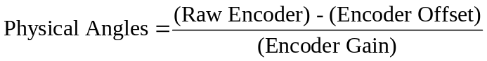

The Encoder Offset and Encoder Gain values must originally be found by following some indications. Once these values are known, they are used within the arm C++ classes to compute the physical angles.

Encoder Gain
The encoder gain is simply the number of pulses per revolution in the encoder. The number of pulses may be different for different encoders and needs to be checked when first acquired. The values for the Right Arm and the Left Arm are shown below:

Right Arm = [-5092, 5092, 4244, -4244, 636.6, -636.6]

Left Arm = [-5092, -5092, 4244, -4244, 636.6, -636.6]

Encoder Offset
The encoder offset is the value of the encoder when the arm is in the home position. For ISAC the home position has been determined to that of an “L” shape. To find out the raw encoder values for each of the joints at the home position one must do the following:

Part 1
- Turn the arm ON.
- Move the arm to the home position by using the program ArmTest.exe.
The program is located at: O:\System\Tools\Softarm Encoder Arm Test
- When the program is opened the first time, it will be controlling: Device – Interface 0, which controls the hand. Double-click on ArmTest.exe again and Device – Interface 1 will open, which controls the arm.
- By gently moving the pressure sliders move the arm to the home position. This is done by visual inspection. Try to be as accurate as possible.
- When the arm is at the desired position, write down the values shown for the raw encoder values for each joint, there should be six of them.

Part 2
  - Open the program: O:\System\Tools\Softarm Encoder Arm Test \EncOffsetTool.exe
There is a copy of the program in I:\Src\Tools\Softarm_Encoder_Offset
  - Type the six raw encoder values that you recorded above in the Joint [1-6] fields. Once the six values have been entered, click on Compute and the six encoder-offset values will be provided.

**Note: IF these values are recomputed, they should be reassigned within the constructors of the IMA2_ArmToolsLib components.

Raw Encoder Values
Once the appropriate encoder values are recorded in the constructors, the raw encoder values can be read directly from the hardware and used to compute the physical angles in the C++ classes. In the ArmTools classes, the CSampleIndPressure class, contains a function called the SampleFunction(). This function uses a hardware interrupt defined as IOCTL_SOFTARM_SAMPLE and can retrieve the raw encoder values, which it saves in an internal variable in code. Once the raw encoder values are obtained, the physical angles are computed easily. The next important computation is that of the Logical Angles.

Logical Angles
There is another set of angles used for ISAC as a consequence of its geometry. These angles are called “Logical Angles.” The first two angles, the BASE and SHOULDER, are the same for both sets. However, the other logical angles are functions of some two physical angles. The equations for mapping between the two sets are given by:

LogicalAngle[0] = PhysicalAngle[0];
LogicalAngle[1] = PhysicalAngle[1];
LogicalAngle[2] = 0.5*(PhysicalAngle[2] + PhysicalAngle[3])
LogicalAngle[3] = PhysicalAngle[2] – PhysicalAngle[3]
LogicalAngle[4] = 0.5*(PhysicalAngle[4] + PhysicalAngle[5])
LogicalAngle[5] = PhysicalAngle[4] – PhysicalAngle[5]

These equations can be solved for the physical angles, giving:

PhysicalAngle[0] = LogicalAngle[0]
PhysicalAngle[1] = LogicalAngle[1]
PhysicalAngle[2] = LogicalAngle[2] + 0.5*LogicalAngle[3]
PhysicalAngle[3] = LogicalAngle[2] - 0.5* LogicalAngle[3]
PhysicalAngle[4] = LogicalAngle[4] + 0.5* LogicalAngle[5] PhysicalAngle[5] = LogicalAngle[4] - 0.5*LogicalAngle[5]

Kinematics
(Derivation of the Kinematics can be found in two .pdf files located at:
O:\Components\ArmComponents\KinematicsClass)

ISAC uses Forward and Inverse kinematics to describe the position and orientation of the robot’s frames--usually the end-effector (hand)--as a function of the arm joint angles. The Inverse Kinematics calculate the joint angles necessary to give a frame a certain position and orientation based on the Cartesian coordinates as input. The Forward Kinematics calculates the Cartesian position of the arm based on joint angle position as input.
The orientation of the axis in ISAC might not be straightforward and is thus shown below:

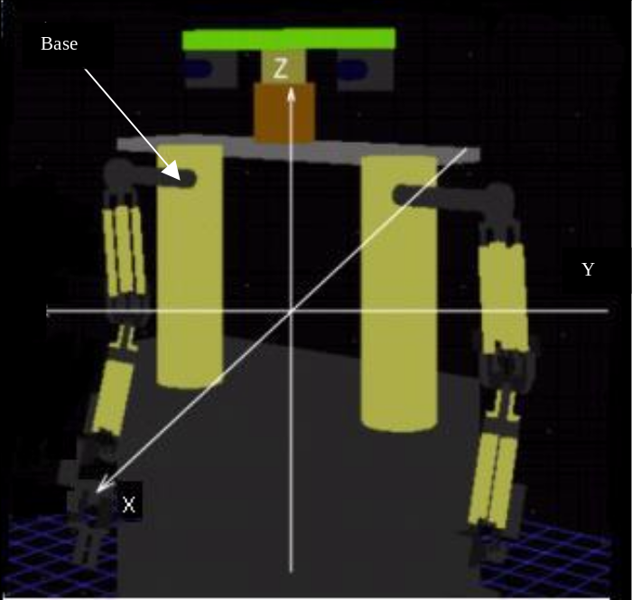
Figure 2 – ISAC Axis System

DH Parameter Table

For a thorough description of DH parameters, please look at .pdf file called “PumaFamilyDerivation.pdf” in the O:\Components\ArmComponents\KinematicsClass folder. Recall that:

a_{i} – is the distance from Z_{i} to Z_{i+1} measured along X_{i}.
α_{i} – is the angle between Z_{i} and Z_{i+1} measured about X_{i}.
d_{i} – is the distance from X_{i-1} to X_{i} measured along Z_{i}.
θ_{i} – is the angle between X_{i-1} and X_{i} measured about Z_{i}.

The DH parameters were derived by following the Puma 560 model, at first glance ISAC’s arm, might not seem exactly the same, but with two small adjustments they behave the same way:
- Consider the rotational joint at the elbow to be part of the wrist,
- Move the wrist to a vertical position (upwards). In this way, with the L-shaped metal plate on that wrist, we can move a hand side-to-side, thus achieving a spherical wrist.

Here is an example of what a Puma arm looks like:
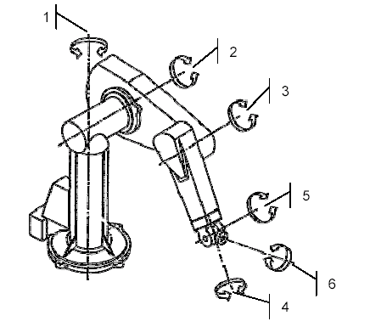
Puma Arm: For ISAC we translate one degree of freedom from elbow to the wrist,
and move the wrist upwards to simulate a PUMA arm behavior.

The DH Parameters for both arms, end up looking like this:

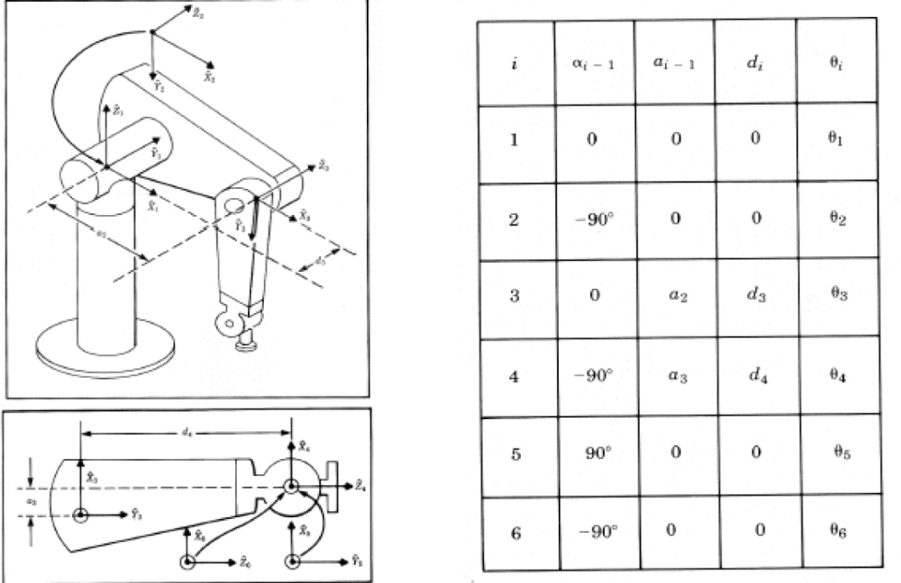

For more, also look at Joachim Schroeder’s thesis at: O:\Documentation\Component Description\Arm \(Schroder 2003) - Position Control.pdf

Forward Kinematics

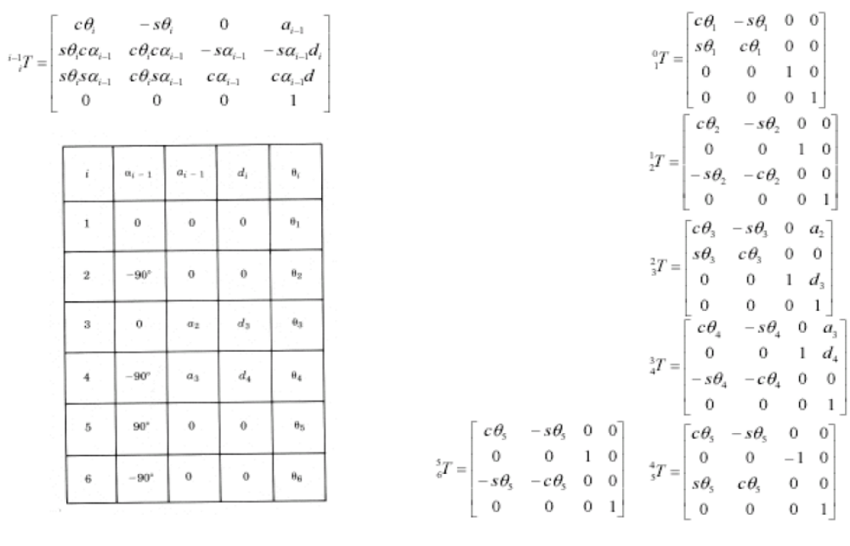

Inverse Kinematics

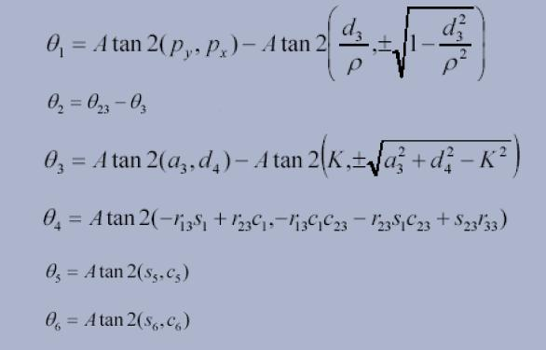

Base and End-Effector Transformations

There are two transformations that need to take place before the Kinematic solutions are complete. The kinematic equations are solved to achieve a transformation from the base to the wrist. But transformations from: the wrist to the end-effector and from the base to the center of the eyes needs to be derived.

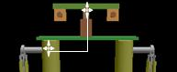
Base-to-Eye Midpoint Transform

BaseXForm[6]
The Base-to-Eye transform is a translation from the base origin to the mid-point between the eyes. The transform evidently is different for both arms in the y-coordinate. Also, consider that after the installation of the new cameras in 2003, this transform changed slightly. If the configuration changes in the future, it should be noted, and the transform changed accordingly.

Currently the BaseXFrom[6] (located in O:\Components\ArmComponents\IMA2_ArmTools\Kinematics.h/cpp) is:

BaseXFrom[0] = -86;
BaseXFrom[1] = -265; // to the mid-point of the cameras
BaseXFrom[2] = -275;
BaseXFrom[3,4,5] = 0;

At this time it will be important to highlight the face that the middle of the cameras is not the middle of both arms. In fact, this point is slightly closer towards the left arm than it is towards the right one. Hence, for the left arm’s y-coord:

BaseXForm[1] = 230;

Whilst previously it had values: -60, -265, -275, 0 correspondingly.

For the EndXForm[6], the changes are more frequent given that in the last couple of years (2003-2006) there has been many changes with the grippers. Make sure that the coordinates reflect the appropriate values for both the right and left grippers.

Control Loop
Figure 2 shows data flow through the agent’s control loop.

Input: The input to the arm control loop is a position command. The position command to the arm can come as either a: DESIRED XYZ POSITION vector signal or a DESIRED LOGICAL ANGLES vector signal. Although the desired xyz position vector signal is more common.

The desired xyz position is converted into desired logical angles through an INVERSE KINEMATICS component. The desired logical angles are then filtered to become FILTERED DESIRED LOGICAL ANGLES.

The filtered angles are used by the SAMPLER, which basically produces three important outputs AND is the component in charge of talking to the hardware (servo valves) to actually move the arm to the position directed by the PRESSURES value. The outputs of the sampler are the DESIRED PHYSICAL ANGLES and the PHYSICAL ANGLES which drive the PID/NONLINEAR CONTROLLER and also produces the LOGICAL ANGLES value which is used by the FORWARD KINEMATICS to output the XYZ position to report the Cartesian coordinates of the arm.

These functions along with the Homing Controller component will be described in more detail later. It is worth noting that this figure will prove to be very useful in understanding the overall behavior of the Arm Agent in its entirety.

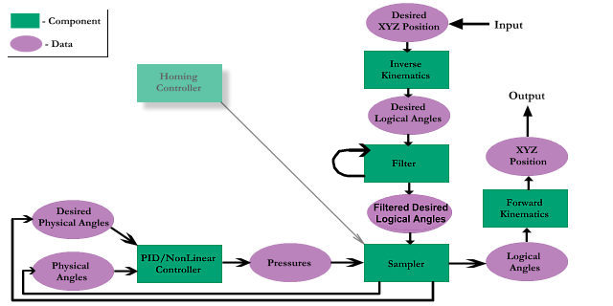
Figure 3 - SoftArm Agent Control Loop

Note!
Whatever changes are done to any of parameters seen above, please make sure to modify the code for the following three programs:
- IMA Arm Class: O:\Components\ArmComponents
- ISAC Simulation: O:\System\Tools\Arm\ISAC Sim
- ArmTest O:\System\Tools\Arm\ArmTest

RightArm Agent

Note:
From 2007 onwards, Popeye was discontinued, and the RightArm Agent and related are running from Hungerforce.

The RightArm Agent is the one in charge in IMA 2.5 of handling the control of the robotic arm and moving it to a desired location whether in Cartesian coordinates of Joint Angle positions.

The RightArm Agent needs a total of 16 components to work as described in this manual. There are five components related to arm control, one state machine, and 10 vector signals (or data) containers. The agent is shown below:

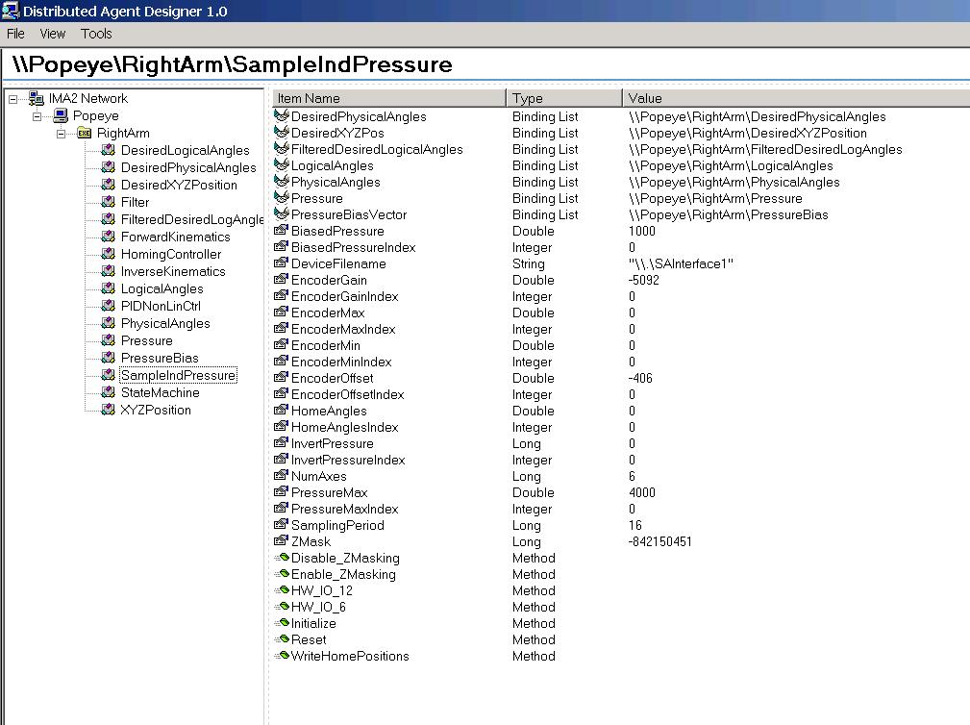
Figure 4 - IMA 2.5 Right Arm Agent

The five main arm components can all be found in code at: O:\Components\ArmComponents.

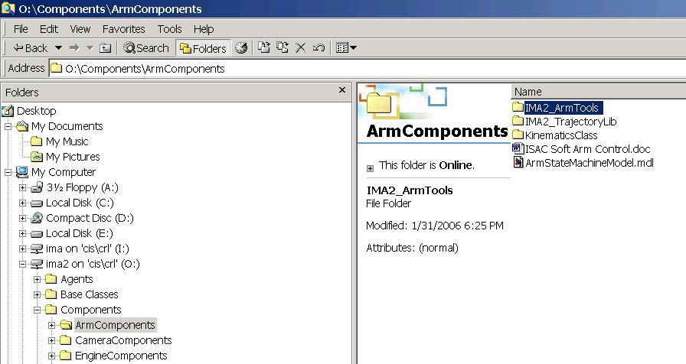
Figure 5 - IMA2 Arm Components

The actual IMA 2.5 components can all be found by opening DAD, and right clicking on the Popeye icon, and selecting Component

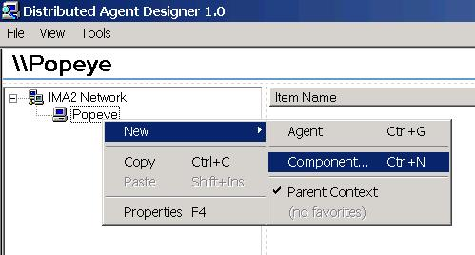
Figure 6 - Selecting a new component

Then, one most select the: “(IMA2 Components) – ArmLib” Icon to open the five main arm components:

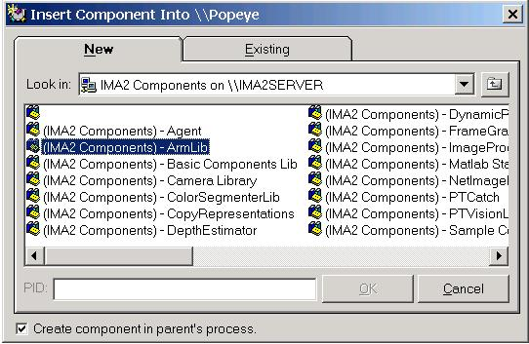
Figure 7 - Inserting Arm Components
Finally, one will see five components for the arm:
- Homing Controller,
- Kinematic Model,
- PID/NonLinear Controller,
- SampleIndPressure, and
- Step Filter.

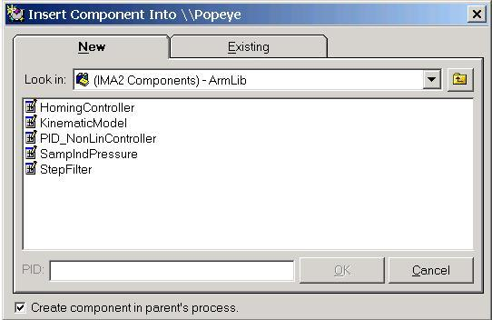
Figure 8 - Five main arm components

If you wish to open the RightArm Agent, all you have to do is open DAD, right click on the Popeye icon, select component, select the existing tab, go to:

O:\Agents\ReleaseAgents\Arm\RightArmAgent.cmp .

Select the agent, and click on open.

It is worth mentioning that all the values for the parameters of the components necessary to run the arm are set in the constructors of the programs and do not need to be changed. However, one has the flexibility to change those values at run time through the interface in DAD.

Components

A more detailed description of each component now follows.

Homing Controller

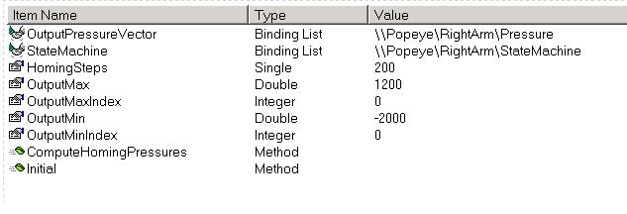
Figure 9 – Homing Controller
The homing controller has two bindings, or connections to other components:

- OutputPressureVector binding connects to -> Pressures VS
- State Machine binding connects to -> StateMachine component

The Pressure Vector binding allows us to connect to the Pressure Vector Signal in the RightArm Agent. The Homing Controller is a program that will compute a series of pressure in such a way that it will move ISAC’s right arm through its whole field of motion.

The motion sequence is as follows:
- Moves up and to the right,
- Crosses his arm around the front all the way towards the left,
- Comes back to a vertical position,
- Lowers the arm and continues to turn the should so the arm moves behind him,
- Moves back forward, until it finishes in the home position.

The Interface function ComputeHomingPressures() contains a series of if, else loops that alter the pressures for each of the arm joints. This pressure information is passed to the vector signal, which in turn is used by the SampleIndPressure component to move the arm. At the end of the loop, there is a connection to the local state machine sending a message to move on to the next state. The state machine evidently receives this message and sends an event to move to the next state.

This component is not necessary to run the control loop but exists to provide a visual image of the behavior of the arm.

Kinematic Model

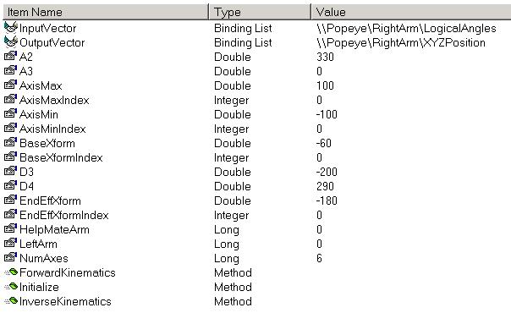
Figure 10 - Forward Kinematics component

The Kinematic Model component can be used to compute forward or inverse kinematics.
This component has two bindings, vaguely named as: Input Vector and Output vector for the reason that forward and inverse kinematics use different inputs and outputs. The figure above for example shows the input and output bindings for the forward kinematics. A summary for both components is shown below:

Forward Kinematics
- InputVector binding connects to -> LogicalAngles VS
- OutputVector binding connects to ->XYZPosition VS

Inverse Kinematics
- InputVector binding connects to -> DesiredXYZPosition VS
- OutputVector binding connects to ->DesiredLogicalAngles VS

The Kinematic Model component is the result of the KinematicModel Class, which is an IMA 2.5 component. However, this class makes use of a standard C Class called SAKinematics to do the computations for all the kinematics. For the forward kinematics the LogicalAngles position received in converted into an XYZRPY position, which is then passed to the XYZPosition VS. The inverse is true of the Inverse Kinematics component. Documentation for Kinematic modeling can be found in any standard text.

PID/NonLinear Controller

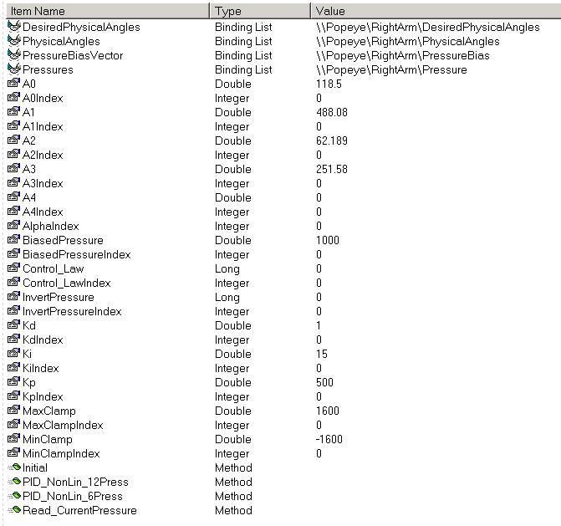
Figure 11 - PID/Non-Linear component

The PID/Non-linear controller has three inputs and one output. All these represented by the bindings.

Inputs:
- DesiredPhysicalAngles binding connects to -> DesiredPhysicalAngles VS
- PhysicalAngles binding connects to -> PhysicalAngles VS
- PressureBiasVector binding connects to ->PressureBias VS

Outputs:
- Pressures binding connects to -> Pressure VS

As its name states it, the component uses a combination of PID and Non-linear controller techniques. The input to the control loop is the error different between the actual joint positions, otherwise called “Physical Angles.” This difference produces an output signal, which represents air pressure to move the arm. As mentioned earlier, this Pressure value is actually used by the SampleIndPressure component to move the arm.

The control law is defined as:

Where the PID law is equal to:

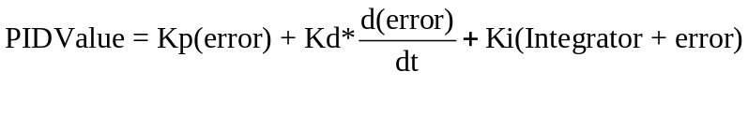
And the Non-linear law is equal to:

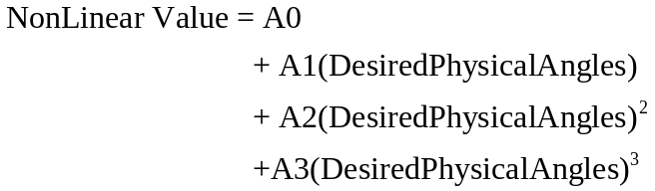

The values for the control variables were computed by experimentation in years past and are set in the constructor for this class.

It is worth mentioning as well, that this combined control law can be run in two ways (notice that there are two interface calls). One function computes six pressures for the six joints, the other one computes twelve pressures for each of the twelve rubbertuators. The latter is used in the state machine loop that runs the control loop for the agent.

SampleIndPressure

The SampleIndPressure component has three inputs and one output. All these represented by the bindings.

Inputs:
- FilteredDesiredLogicalAngles binding connects to -> FilteredDesiredPhysicalAngles VS
- Pressure binding connects to -> Pressure VS
- PressureBiasVector binding connects to ->PressureBias VS

Outputs:
- LogicalAngles binding connects to -> LogicalAngles VS
- DesiredPhysicalAngles binding connects to -> DesiredPhysicalAngle VS
- PhysicalAngles binding connects to -> PhysicalAngles VS
- DesiredXYZPosition binding connects to -> DesiredXYZPosition VS

And has a direct connection to the arm interface through the Device FileName property. The filename of the device for the right arm must be: “\\.\SAInterface1”.
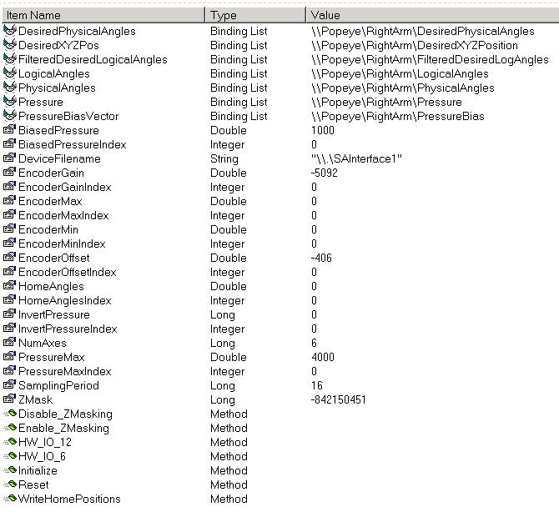
Figure 12 - SampleIndPressure component

Basically what the SampleIndPressure does is use the pressure value computed by the PID/Non-linear controller and add the pressure bias for it. This value is then checked to verify that it is within the physical limits of the rubbertuators/shadow arms (otherwise it is clamped). The value is used by the SampleFunction() to pass the value to the hardware and move the arm.

This component also reads the current values from each of the six encoders found at the joints of the arms and converts these values into Physical Angles.

The equation used to make this computation is:

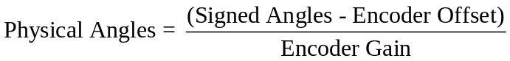

The equations used in the Theory section of this manual are used to convert Physical Angles into Logical Angles and the same for the desired quantities. Again all values are set in the constructor and do not have to be changed unless one want to modify something for testing purposes – one can do that at run time through DAD.

Note: There is a WriteHomePositions() function. This is an important function for the appropriate deployment of the agent in the state machine. As it will be shown later, in the third state of the state machine, this function is called. The latter will read the appropriate home positions in both Cartesian and joint angle space and write those to the DesiredXYZPosition and DesiredLogicalAngle vector signals. This allows the arm to start appropriately at the home position.

Step Filter.

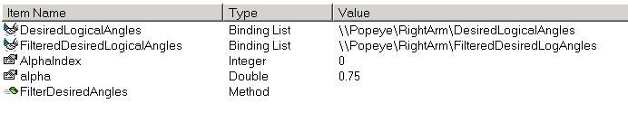
Figure 13 - Filter component

The Step Filter component is in charge of filtering the DesiredLogicalAngles signal in such a way that it closes the distance between the actual and prior desired signals.

Inputs:
- DesiredLogicalAngles binding connects to -> DesiredLogicalAngles VS
- FilteredDesiredLogicalAngles binding connects to -> FilteredDesiredPhysicalAngles VS

Outputs:
- FilteredDesiredLogicalAngles binding connects to -> FilteredDesiredPhysicalAngles VS

The way two inputs are described above might be confusing. However this is done to clarify how the component works. There are two inputs to the components, where FilteredDesiredLogicalAngles should rather be called OldFilteredDesiredLogicalAngle signal.

Once the more recent and older signals are obtained, a new filtered signal is computed by the following equation:

FilteredDesiredAngle = Alpha(OldFilteredDesiredAngle) + (1 - Alpha)DesiredJointAngle

Where Alpha is typically = 0.75.

This result is then the new output and is pushed unto the FilteredDesiredLogicalAngle vector signal to increase its history length (or SignalLenght) by one.

State Machine

The state machine for this agent was created in Matlab and can be found at:
O:\Agents\ReleaseAgents\Arm\armagent.mdl.

The state machine is show below. Notice that each state has a name, it has been sought to give as intuitive names as possible to each state to facilitate understanding.

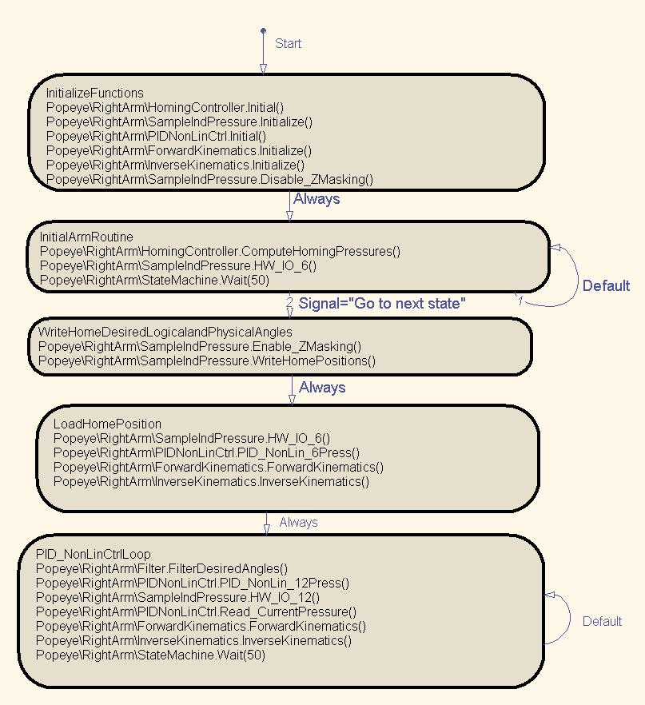
Figure 13 – State Machine

The state machine has five different states. They will each be explained below.

State 1: Initialize Functions
This state is simply used to call all the initialization functions for all the components that will be used in this agent. These initialization calls reset important variables or assign them specific values.

State 2: InitArmRoutine
This state calls the HomingController.ComputeHomingPressures() function which computes the pressure values for the arm routine, which are used by the SampleIndPressure.HW_IO_6() function to actually move the arm. Notice that this state has two loops. The default loops goes back to the same agent. It only moves when a signal represented by the string “Go to next state” is received. The homing controller automatically produces this signal when it reaches the end of its initialization routine.

As mentioned earlier, this state is not necessary but is useful so that the user can visually inspect that the arm is working well.

State 3: WriteHomeDesiredLogicalandPhysicalAngles
This state is very important if the arm is to move to the home position after the initialization routine it went through. There is one crucial call here and that is: SampleIndPressures.WriteHomePositions(). This function as mentioned earlier will write the DesiredXYZPositions at the home position (410, -415, -605) so that the inverse kinematics will later convert these. It also sets the appropriate DesiredLogicalAngles at (0, -1.57, -3.142, 0, -1.57, 0).

State 4: LoadHomePosition
This state is used to actually move the arm to the home position and be ready to move elsewhere.

State 5: PID/NonLinearCtrl Loop
This is the last state in which the state machine will continue for as long as the arm is moving. In it are the necessary calls output pressures, move the arm, and computed current positions.

Practicals
This section will explain how to activate and stop the state machine in a safe manner.

Starting the StateMachine
Once the RightArm agent has been opened in DAD, click on the StateMachine component and click on Load. The file that it will load has been saved, so it always reloads. But this file can be changed if a different state machine will be used. Once it has been loaded, click on Start. The state machine will begin its execution.

Stoping the StateMahcine
If at any moment you wish to stop the state machine, click on Stop, and then move over to the SampleIndPressure component and click on the function Reset(). This will deflate the arm in a safe manner.

For more information please look at Christina Campbell’s documentation on the State Machine at:
O:\Documentation\Manuals\State Machine\State Machine Documentation - 1.0.doc

Conclusion

As it has been showed, a presentation of the hardware, theory, and software components for the ISAC arm with an emphasis on the concepts under the IMA architecture has been done. It has been sought to present in a clear and detailed fashion the concepts contained in the control loop of the arm and the way it is organized under the RightArm agent in the IMA 2.5 architecture. Each critical component was listed and its inputs, outputs, and functionality were described. It is evident, as even Figure 2 shows, the control loop moves around two main components, which are the PID/Non-Linear controller and the SampleIndPressure component. It is these two that have the more complex tasks in the system and the ones that make important use of the data that flows in the system. One should find that these classes are well documented in code and can be understood if used in conjunction with this manual.

References

- Alford, M. Cambron, A. Srikaew, “ISAC Operation Manual,” CIS Technical Report 99-2.
- D. G. Caldwell, G. A. Medrano-Cerda, and M. Goodwin, “Control of Pneumatic Muscle Actuators,” IEEE Control Systems, Feb. 1995.
- T. Pack, M. Iskarous, and K. Kawamura, “Comparison of Fuzzy and Nonlinear Control Techniques for a Flexible Rubbertuator-Based Robot Joint,” Proceedings of the Third International Fuzzy Systems and Intelligent Control Conference, 1994.
- O:\Components\ArmComponents\IMA2_ArmTools\IMA2_ArmTools.dsw<break>

In later years some of these rubbertuators have been replaced by Shadow Arms. The reason being is that Rubbertuators are not fabricated anymore.
The C++/ATL Project for IMA2 can be found at: O:\\Components\ArmComponents\IMA2_ArmLib For IMA 1.0 the class can be found at: I:\\Source\Mecahisms\ArmTools\ArmTools
More information about IMA 2.5 in general or other components can be found at: O:\Documenation

